# V-MANAGER OPERATION GUIDE

Version: 3.0

Choosing a Server

For most operations in V-Manager’s SharePoint client, a Server must first be selected. Servers are registered automatically when a Vmgr.Services Windows Service is installed and started. When registered, the Server will appear in a list of selectable servers on the Server Selection page.

Note: if you attempt to access a V-Manager SharePoint page, and no server was selected, you will be redirected to the Server Selection page where you can select a server. Once a server is selected, a Select Server Success dialog should appear. Click OK, and you will be redirected back to the page you were originally trying to view.

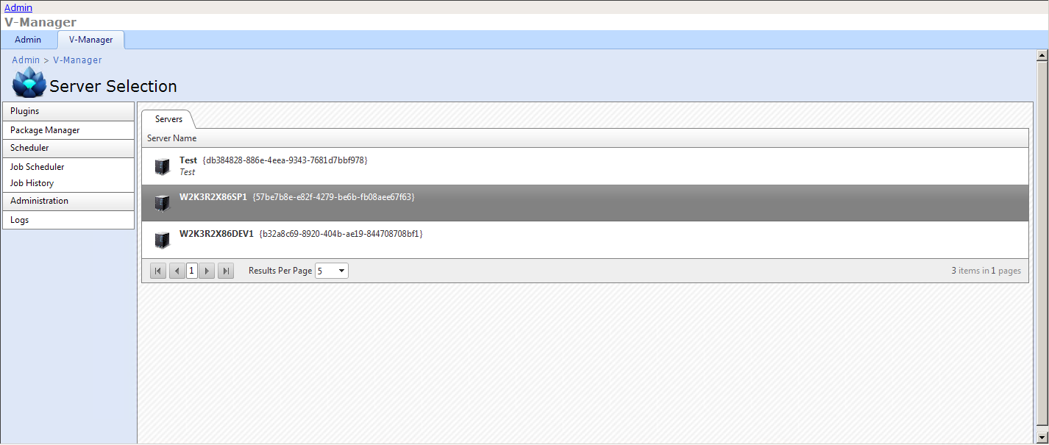

If, at anytime, a new server selection is desired, click the selected server hyperlink in the top-right corner of most application pages.

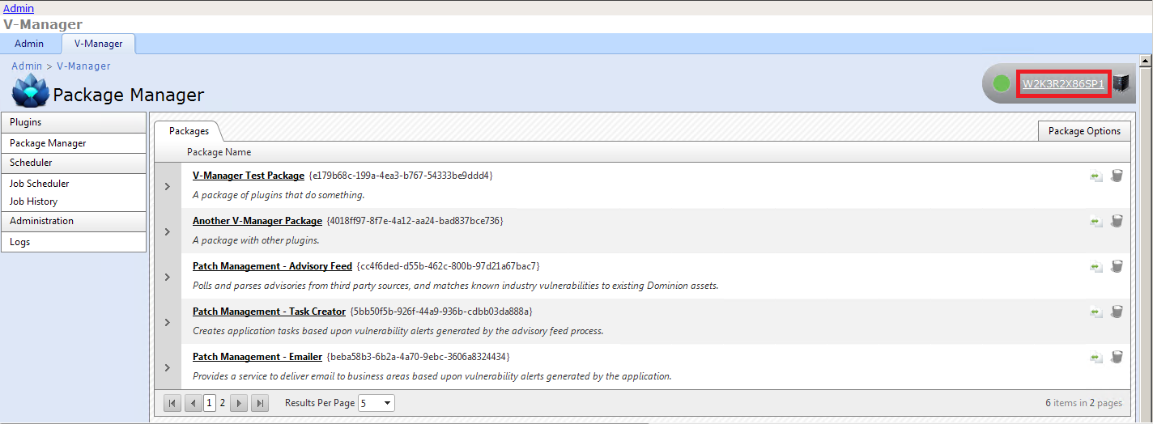

Note: the circular icon just to the left of the selected server hyperlink will be green when the Vmgr.Services Windows Service is started. The same circle will appear white when the service is not started.

Uploading Packages

V-Manager only accepts package files that have the *.vmgx file extension. In SharePoint > V-Manager, using the Quick Launch Navigation Bar, navigate to Package Manager. From the Package Options menu, choose “Upload plugin package”. Select the checkbox “Overwrite package if already present.” if applicable **before choosing your file**. Click “Select” to browse for the *vmgx file you wish to upload. Once you have found your *.vmgx file, select it, then choose “Open”. The file will be uploaded, validated, transferred to the selected server, and automatically loaded for immediate use.

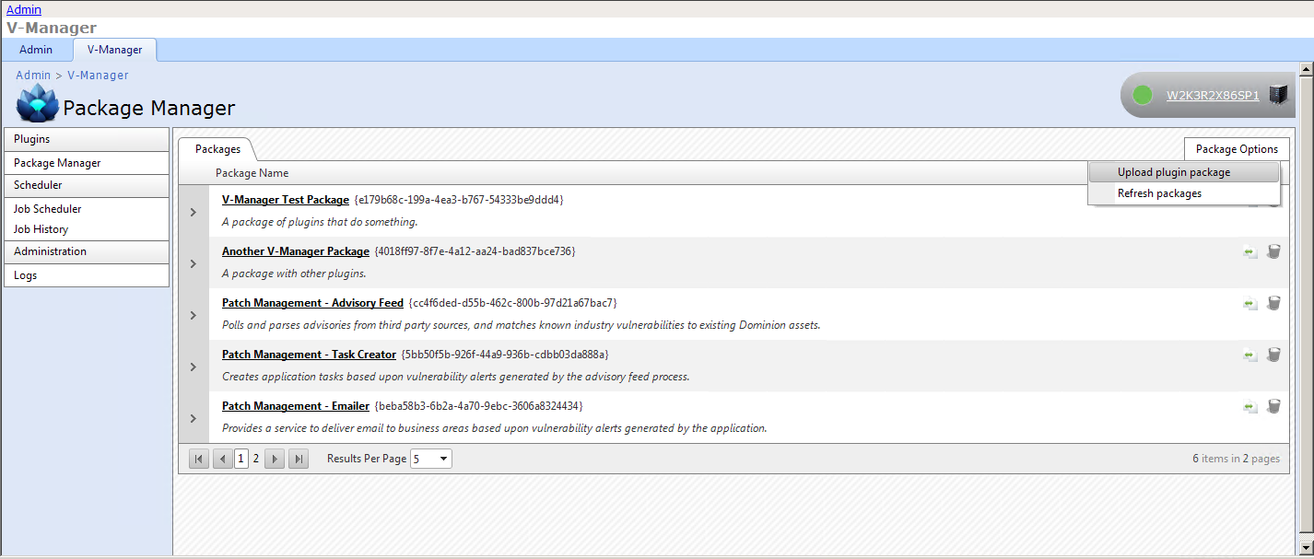

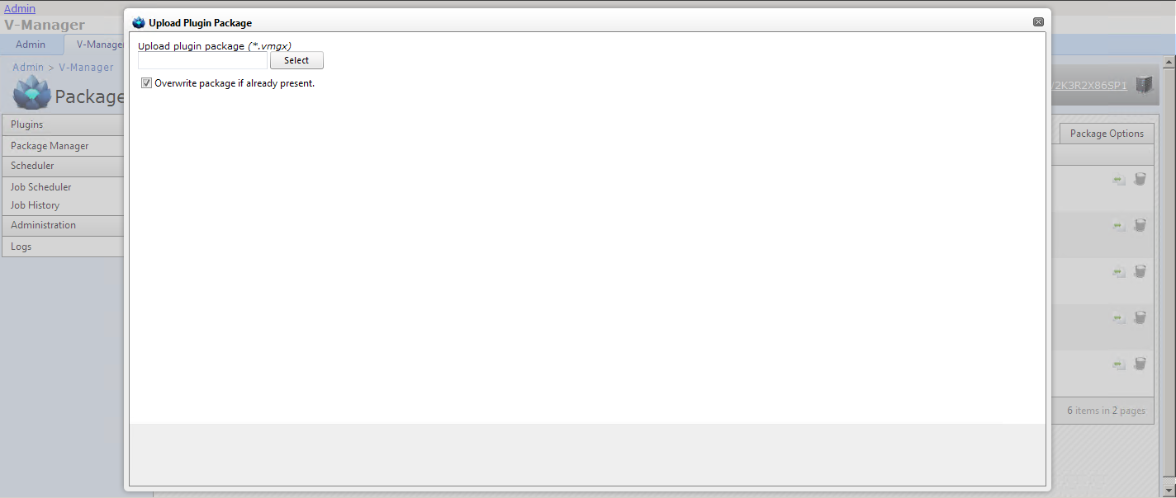

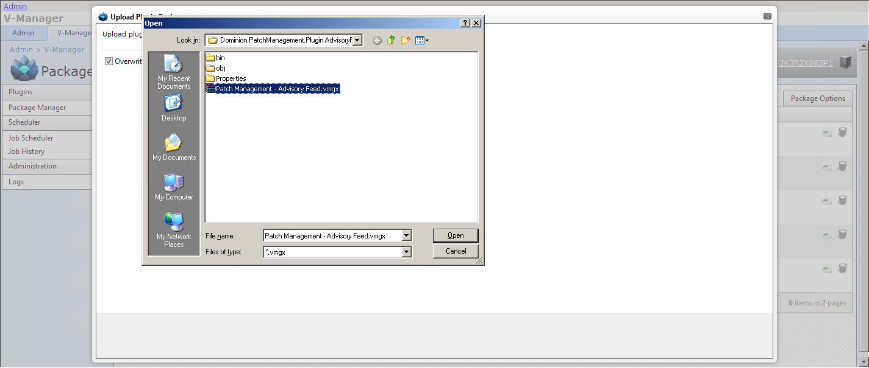

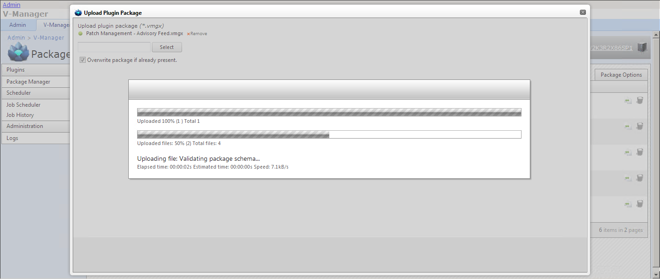

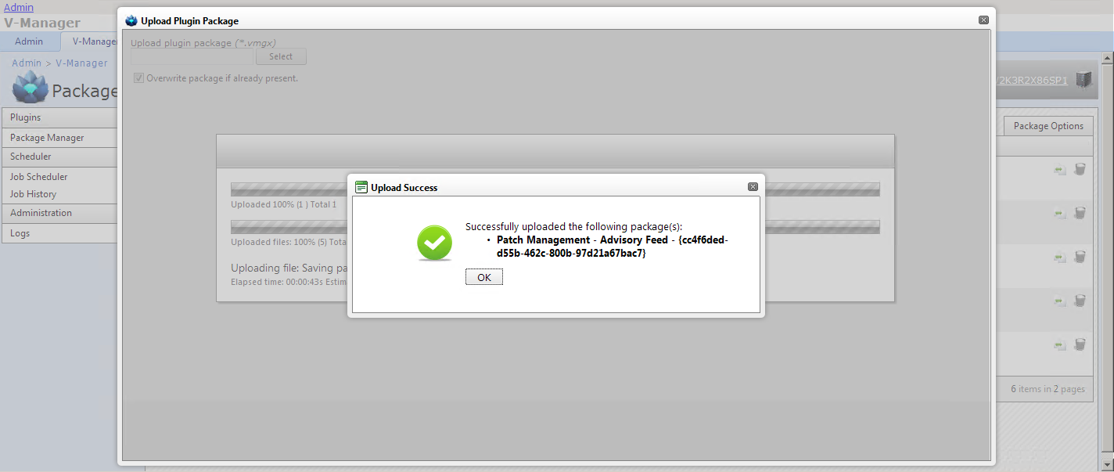

Once a package is uploaded, Click OK, and verify the package has each plugin defined within the package.

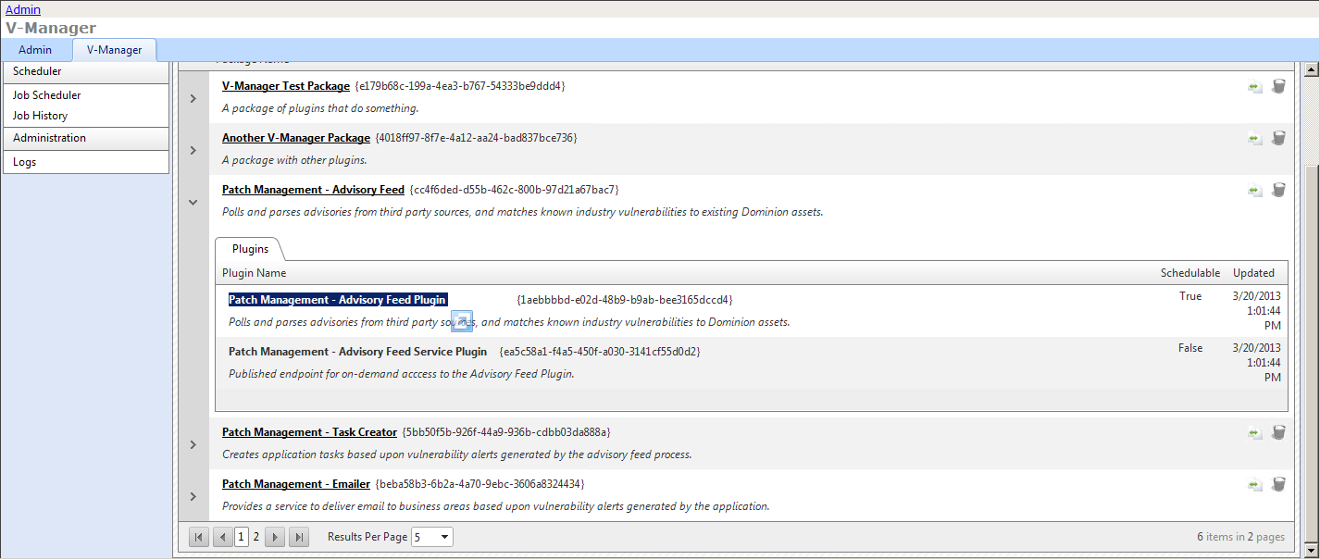

Note: most plugins within a package will be schedulable. Plugins that are not schedulable are typically for on-demand functionality exposed through WCF end-points; however, there could be other purposes as well.

Deactivating an Deleting Plugins

You can deactivate (or pause) a package. When you click on the pause icon from the Package Manager, each schedule defined for each plugin is unloaded and the unique appdomain its job runs under is removed from memory. Clicking the play icon will recreate the each plugin’s schedule and automatically start a new job to fire at the next scheduled time, if a schedule already exists.

Pausing or playing a package is different than deleting it. When you click the delete icon, the package and all related data is deleted from the database. This means, all schedules are removed from memory, then all associated triggers, jobs, schedules, plugins, and the package itself are then to be deleted and permanently removed.

Scheduling Plugins

Uploaded, active, schedulable plugins can be scheduled by using the Quick Launch Navigation Bar, and navigating to Job Scheduler. Job schedules are mapped to a selected plugin, so the schedule will only run on the server where the plugin’s package was uploaded or moved.

The Job scheduler supports a number of calendar-based recurrence patterns, as well as minutely, hourly, and daily schedules. Additionally, once a schedule is created, the Job Scheduler schedule will show a plain-language depiction of the schedule.

To create a schedule, select “Add new schedule”. An “Edit Schedule” dialog will appear allowing you to choose a plugin, and also define a schedule for the plugin to run.

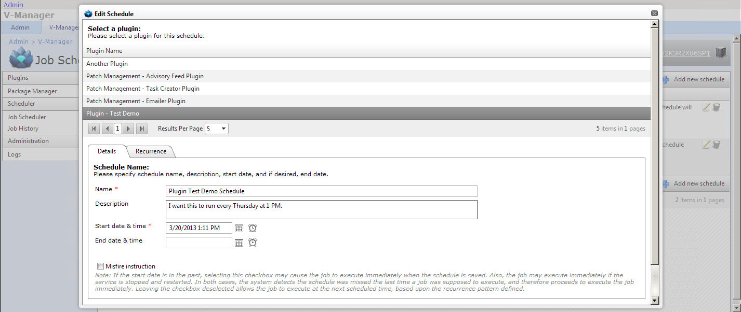

Once a plugin is selected, give the schedule a brief name and description, then select the Recurrence tab to define how often the schedule will invoke the plugin.

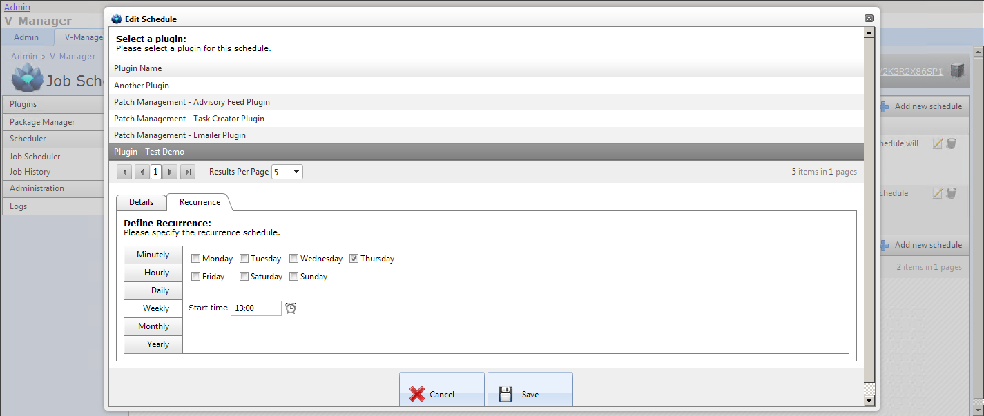

Note: once a schedule is created for a plugin, that schedule cannot be reassigned to another plugin.

Note: on the Details tab, in the lower-right corner, there is a checkbox for “Misfire instruction”. When the Vmgr.Services Windows Service loads a plugin, and subsequently creates a schedule for it, the service checks the time the schedule should start. If the checkbox is NOT selected, and the “Start date & time” happens to be in the past at the moment the service creates a job for the plugin, a “misfire event” will occur. This is sort of like a false start, and the plugin will NOT be executed. But, if the checkbox is selected for this same scenario, the service will create a job and run it as soon as possible. Selecting this checkbox will depend upon the criticality of the plugin, and how it should behave after an outage period.

Click Save to create the schedule. If the creation of the schedule is a success, it will be immediately evaluated and a new scheduled job will be created.